Introduction to the HVAC Zoning and Vent Control App

The HVAC Zoning App for Hubitat controls a Heating, Ventilation, and Air Conditioning system.

* Single and Two-stage Forced Air Heating and Cooling Equipment (Heat pumps not presently supported)
* Zoned and Non-zoned duct systems, including systems with controllable registers and duct fans
* Ventilation equipment, including ventilation equipment that utilizes the air handler blower

***Why control the HVAC system from Hubitat?***

* Zone control hardware does not have access to as much information as a home automation system and therefore cannot take advantage of that information to control the HVAC system.
* It is expensive to include a lot of options in zone control hardware, so available hardware solutions provide only a few configuration options. Software based solutions can offer much more flexibility and customization.

***Requirements***

* A Hubitat-connected thermostat in each zone
* A Hubitat-connected thermostat or a temperature sensor in each subzone (controllable vents or duct fans)
* Hubitat-connected switch devices to control the equipment (Zooz ZEN16 is recommended)

***What if Hubitat goes offline sometimes?***

The system may be configured such that it reverts to operating as a single zone system if Hubitat is offline.

Table of Contents

Forced Air HVAC Systems Pg. 3

This section describes different types of duct systems and defines some terminology.

Zone Control and Equipment Control in the App Pg. 12

This section is an overview of the algorithms implemented in the App for controlling heating and cooling equipment and selecting zones.

Ventilation Systems Pg. 15

This section describes different types of ventilation systems.

Vent Control Logic in the App Pg. 16

This section is an overview of the algorithms implemented in the App for controlling ventilation equipment.

Physical Device Setup Pg. 19

This section illustrates suggested ways to connect Hubitat-connected switch devices to the HVAC system to enable the App to control the equipment.

Downloading, Installing, and Configuring the App Pg. 29

This section describes the settings available to the user to customize the App for their HVAC system and their preferences.

Forced Air HVAC Systems

Figure 1 illustrates an air handler, which is the heart of a forced air Heating, Ventilation, and Air Conditioning (HVAC) system. An air handler includes a blower which draws air from return ductwork and propels it through at least one heat exchanger and through supply ductwork to various rooms in a residence. In the air handler illustrated in Figure 1, there are two heat exchangers: a furnace to heat the air during cold weather and an air conditioning evaporator to cool the air during hot weather. Only one of the two heat exchangers would be used at a time. In climates that do not need both heating and cooling, one of the two heat exchangers may not be present. Also, some air handlers use a heat pump heat exchanger which can alternately provide either heating or cooling. (Note: the App does not currently support heat pumps.)

The air handler also includes controls which receive signals indicating when to provide heating, cooling, or fan. As will be discussed later, these signals may come directly from a thermostat or may come from a zone controller. If air conditioning is present, the controller will send signals to a compressor unit that is located outdoors. In response, the compressor will circulate refrigerant through refrigerant lines to the evaporator.

Some air handlers provide two stages of heating, cooling, or both. The first stage usually provides about 60% as much heating or cooling capacity as the second stage, although the percentage varies between models. When the full capacity is not needed to maintain the desired temperature, using the first stage is more efficient and provides better comfort. There are various control strategies for deciding when to use first stage and when to use second stage. A common strategy is to use first stage for a set amount of time (10 to 12 minutes) and then go to second stage for the remainder of the heating or cooling call. More sophisticated strategies require more inputs. Modulating equipment can adjust capacity to effectively any level between a minimum capacity and a maximum capacity. (Note: the App does not currently support modulating equipment.)

Many ventilation systems utilize the air handler to circulate fresh air from outdoors throughout the residence. In these systems, the fresh air enters the system via the return ductwork. Ventilation will be discussed in more detail later.

Blower

Filter

Furnace

AC Evaporator

Supply Ductwork

Return Ductwork

Ventilation

Air Handler

Controls

Compressor Calls

Heating Calls

Cooling Calls

Fan Calls

Refrigerant Lines

To Compressor

Fig. 1 - Air Handler

Figure 2 shows the supply side of a typical un-zoned forced air HVAC system. The air handler takes in air from a return duct (not shown), and then blows heated or cooled air into a plenum. From the plenum, the air flows through one or more trunk ducts. Branch ducts conduct the air from the trunk ducts to registers in individual rooms. Air from the rooms then flows back to the air handler through the return ducts.

A thermostat measures the temperature of the air and compares it to a heating setpoint, a cooling setpoint, or both. In heating mode, when the air is cooler than the heating setpoint, the thermostat sends a heat call to the air handler, causing the air handler to run in heating mode to warm up the interior air. Once the air at the thermostat is warmer than the heating setpoint, the heating call ends and the air handler shuts off. To avoid cycling on and off too frequently, the thermostat doesn’t call for heat until the air is a little less than the setpoint and doesn’t end the heat call until the air temperature exceeds the setpoint by some margin. Cooling mode works similarly. The thermostat calls for cooling when the air temperature is a little above the cooling setpoint and ends the cooling call when the air temperature has decreased below the cooling setpoint by some margin.

Designers of the duct system try to set up airflow rates to each room based on average heat loss (or gain) rates. Upstairs rooms tend to have high cooling loads relative to their heating loads. If the designer sets the airflow to these rooms based on heating loads, they end up being under-cooled during summer. If, on the other hand, the designer sets the airflow to these rooms based on cooling loads, then they tend to be over-heated during winter. The designer may end up picking a middle level with the result that the upstairs rooms end up a little too warm all year. Basements, on the other hand, tend to have very low cooling loads relative to their heating loads.

Sometimes, a few rooms may temporarily have unusually high internal heat gains, for example from sunshine coming in particular windows, people gathering in particular rooms, cooking, running a fireplace, etc. Designers of un-zoned ductwork cannot do anything about these temporary differences between rooms. The system makes the space around the thermostat comfortable but other spaces may be uncomfortably warm or cold.

Air Handler

Plenum

Trunk

Master Bedroom

Master Bathroom

Bedroom 1

Bedroom 2

Bathroom

Kitchen

Laundry

Bathroom

Family Room

Dining Room

Branch Duct

 Tstat

Fig. 2 - Single Un-zoned Ducted HVAC system

Figure 3 shows a HVAC system with two independent air handlers and duct systems. This solves the problems with upstairs and downstairs having different loads. The upstairs system may have a larger air conditioning capacity and a smaller heating capacity than the downstairs system. The upstairs system uses its own thermostat, so it runs when and only when air upstairs needs conditioning. There can still be variations between rooms on each of the floors based on unequal internal gains.

A drawback of this approach is that it requires two air handlers and, usually, separate air conditioning compressors. These tend to be the most expensive parts of the system. Although the equipment can be smaller, two units are considerably more expensive than one unit with double the capacity. This setup is common in two story houses in regions of the country where basements are not common. It is uncommon for a residence to have more than two independent ducted systems.

Air Handler

1

Plenum

Trunk 1

Master Bedroom

Master Bathroom

Bedroom 1

Bedroom 2

Bathroom

Kitchen

Laundry

Bathroom

Family Room

Dining Room

Trunk 2

 Air Handler

2

Plenum

 Tstat

 Tstat

Fig. 3 - Multiple Un-zoned Ducted HVAC systems

Figure 4 shows a two-zone ducted HVAC system. Like the dual un-zoned system of Figure 3, the upstairs rooms and downstairs rooms are served by separate trunk ducts. However, both truck ducts are served by a single air handler. Zone dampers open and close to either allow air to flow into a truck duct or block air from flowing into a trunk duct. Each zone has a separate thermostat. A zone controller takes in commands from the thermostats and sends commands to the air handler and to the zone dampers.

If the downstairs thermostat is calling for heat but the upstairs thermostat is not, the zone controller opens the damper for the downstairs, closes the zone damper for the upstairs, and commands the air handler to produce heat. If both zones call for heat, the zone controller opens both zone dampers. If the zones have conflicting calls, the zone controller must choose which call to serve. Most commonly, this happens when one zone calls for heating or cooling while the other zone calls for fan only. In that case, the zone controller would likely give the heating or cooling call preference and ignore the fan command until the heating or cooling call is satisfied. It is rare to have one zone call for heating while another zone calls for cooling, but it can happen. In that case, the zone controller must alternate or give one type of call preference.

Two zone and three zone residential systems are common. However, it is problematic if any zone is too small relative to the size of the whole system. The air handler must be sized to serve the heating and cooling loads of the whole house. When only the small zone is calling for heating or cooling, the air handler may produce more airflow than the single zone can handle. Pushing that much air through a single trunk duct and a few branch ducts may result in excessive pressure which can be harmful to the fan motor. It may also be noisy. This problem is exacerbated if the residents shut off the airflow to some of the registers, either intentionally or by blocking them with furniture or something else.

In addition to partitioning the house into zones as equally as feasible, there are a few things a system designer can do to mitigate the small zone issue. Some systems have a bypass duct between the plenum and the return duct with a damper that automatically opens if the pressure exceeds a threshold. Opening this damper reduces the amount of air going through the remainder of the ductwork. However, the air flowing into the air handler is warmer in winter and cooler in summer which can be problematic. In summer, the cooler air entering the air handler increases the likelihood of frost on the heat exchanger coils, making the heat exchanger much less efficient, and possibly causing equipment damage. (see <https://www.greenbuildingadvisor.com/article/the-achilles-heel-of-zoned-duct-systems> )

A better remedy is to adjust the closed position of some of the dampers such that some air flows into those zones even when they are not calling for heating or cooling. That works as long as the residents don’t close off registers.

Air Handler

Plenum

Trunk 1

Master Bedroom

Master Bathroom

Bedroom 1

Bedroom 2

Bathroom

Kitchen

Laundry

Bathroom

Family Room

Dining Room

Trunk 2

 Zone Controller

 Tstat

 Tstat

Zone Damper

Controllable Register

Duct Fan

Fig. 4 - Zoned Ducted HVAC system

Residents often do modify the duct system. They may have rooms that they use infrequently, and they want to keep those rooms less conditioned to reduce heating and cooling bills. Sometimes, a room may tend to run warm or run cold relative to other rooms. As shown in Figure 4, there are controllable registers for the dining room on the first floor and for one of the bedrooms on the second floor. These may be electronically controlled, such as Keen (see <https://keenhome.io/pages/how-it-works> ). When these are closed, the respective zone effectively gets even smaller. It may end up smaller than the duct system designer planned for. Another possible modification is a duct fan to increase airflow to under-served rooms, such as a room that is far from the air handler.

Zone Control and Equipment Control in the App

General Principles of Operation

Like a conventional zone controller, the App receives requests from each zone, decides which requests it can serve, then selects the zones to be served and commands the equipment accordingly. In a conventional zone controller, the requests are binary. A zone is either requesting heat or not requesting heat. With the App, the zone requests a specified airflow rate. The App ensures that no more than the requested airflow rate is delivered to that zone. To accomplish this, the App needs information about the airflow capacity of each zone and the airflow provided by the equipment. This information is entered during setup. Exact data is not needed to make the system function properly. Rules of thumb should typically be adequate, as discussed in the sections below about describing your system to the App. These settings can be changed later if necessary.

There are a number of opportunities for users to specify how the App should handle various situations. App settings are employed for user inputs that would be changed infrequently once the system is set up. For inputs that are likely to change on a frequent basis, the App uses switch devices. The user indicates what switch to use during setup and then manipulates the switches as desired during use. Most often, virtual switches are preferred over physical switches for this purpose. The user may turn these switches off and on via a dashboard or may set up rules to set the switches based on conditions sensed by other devices. In this way, behavior of the HVAC system may react indirectly to inputs never envisioned by the App programmer. This is how the Hubitat HVAC Zoning App makes use of the information that is not typically available to a zone control board from the furnace manufacturer.

Similarly, the App outputs are switch devices. During setup, the user specifies which switches the App should set for each output. In some cases, the user may specify a physical switch that directly controls the system. In other cases, the user may create a virtual switch and link that switch to physical devices through rules.

For two-stage equipment, the App generally uses only first stage as often as possible because that is most efficient and provides the greatest comfort. The App commands second stage when necessary to keep up with especially high demand or to accomplish a significant change in temperature, such as when recovering from a setback. The App commands second stage if first stage has been operating continuously for a user selectable amount of time. If first stage is insufficient to satisfy the residence’s heating or cooling load, second stage will eventually be commanded. Selecting a longer amount of time reduces the utilization of second stage, reducing energy use and improving comfort most of the time, at the expense of occasionally not maintain the setpoint temperature as accurately. The user can also set a temperature difference from setpoint to trigger second stage. The App selects second stage any time that any zone is further from its setpoint than specified. This typically happens because the setpoint was changed and this setting triggers second stage to help the system catch up to the new setpoint rapidly. The system will never select second stage unless the zones calling for heating or cooling have enough capacity for second stage.

The App is structured hierarchically. There is a main App which controls the equipment and child apps for each zone. Any subzones, such as controllable registers (i.e. Keen vents) or duct booster fans are handled by another level of child apps under the corresponding zone app. Like other home automation apps, there is no user interface. However, it is useful to set up a dashboard with all of the input and output devices.

Figure 5 illustrates the overall equipment control logic. When there have been no heating or cooling calls for awhile, the system is in Idle state. When a heating call starts, the system checks to see whether it can be served. If the zones calling for heat collectively have enough capacity for first stage heating, then the request can be served. If the capacity of calling zones is not sufficient, the App looks for zones that volunteer to accept heat and treats those as if they are calling for heat. The App turns on the heating equipment, selects the calling zones, and goes into HeatingL (locked heating) state. It stays in this state for a fixed amount of time to ensure that excessively short heating runs are avoided. Then, it transitions into Heating state. It continues in heating state until there is no longer a servable heat call. After it ends a heat run, it transitions into a PauseH state for a fixed amount of time to ensure that there is a sufficient interval between runs. At the end of that interval, it goes into IdleH state, in which it will serve heating calls that arise but will not serve cooling calls. If no heating calls occur for a set time, it transitions back to Idle state where either type of calls may be served. This ensures that it does not rapidly transition between heating and cooling. These intervals are user adjustable. Cooling is handled in an analogous fashion. Whenever the system is an Idle or Pause state, the blower may be operated to serve fan requests or for ventilation as described in more detail in a later section.

When a zone is being served, the App checks whether any subzones should be selected to also be served. For each subzone, the user may select from several rules for determining whether the subzone should join heating and cooling calls of the zone. If a subzone has a thermostat (as opposed to just a temperature sensor), then the subzone can initiate a heating (or cooling) call if the zone to which it belongs has volunteered to accept heating (or cooling). The user selects conditions for when each zone should volunteer to accept heating or cooling. The user may optionally specify a switch to indicate when the zone is occupied. If an occupied switch is specified, then different conditions may be selected for occupied and unoccupied.

E: Heat call starts

A: turn on heat

E: Min Mode Change Time

E: Heat call ends

A: turn off heat

E: Cooling call starts

A: turn on cooling

E: Min Mode Change Time

E: Heat call starts

A: turn on heat

E: Min Idle Time

PausedH

E: Min Heat Time

IdleH

HeatingL

Heating

Idle

E: Cooling call starts

A: turn on cooling

E: Min Idle Time

PausedC

E: Min Cool Time

E: Cooling call ends

A: turn off cooling

IdleC

CoolingL

Cooling

Fig. 5 – Equipment Control Logic

Ventilation Systems

Indoor air tends to get polluted over time due to activities inside the house. Breathing reduces the concentration of oxygen and increases the concentration of carbon dioxide. Activities like cooking tend to produce Volative Organic Compounds (VOCs) some of which are unhealthy. Some items within a home may off-gas hazardous VOCs. Therefore, it is necessary to regularly exchange stale indoor air for fresh outdoor air. However, excess air exchange increases the heating and cooling loads and costs. Older homes typically are not very airtight, so these homes often experience excessive air exchange, leading to higher heating and cooling cost. To combat these costs, builders have learned how to build houses that have low air leakage. In newer homes or homes that have been upgraded to be more airtight, it is necessary to use mechanical systems to intentionally bring in an appropriate amount of fresh outdoor air.

There are several types of mechanical ventilation systems. An exhaust only system uses a fan, such as a bathroom fan, to blow air out of the house. That depressurizes the inside of the house causing air to come in wherever there are leakage paths. Supply ventilation, on the other hand, uses a fan to blow outdoor air into the house, pressurizing the house and causing air to leave through leakage paths. Balanced systems blow approximately equal amounts of air into the house and out of the house. With a Heat Recovery Ventilator (HRV), the incoming and outgoing air streams go through a heat exchanger such that the incoming air is preconditioned to be near the same temperature as the outgoing air. Enthalpy Recovery Ventilators (ERVs) exchange both heat and moisture between the air streams.

With supply ventilation and balanced ventilation, the incoming fresh air should be distributed around the house. (Exhaust ventilation doesn’t provide an opportunity to control how fresh air is distributed.) Some systems use separate ventilation ductwork to distribute the fresh air. In other systems, the fresh air is injected into the return ductwork, as shown in Figure 1, and the air handler distributes the fresh air through the supply ductwork. This is referred to as an interconnected ventilation system. Interconnected ventilation systems are cheaper to install than systems with separate ductwork. However, the operating costs are higher because the blower must run more than it otherwise would in order to distribute the fresh air.

The fraction of time that a ventilation system needs to run depends on what is happening in the house. When there are many guests in the house for a holiday meal, a lot of ventilation is needed. When only a couple people are in the house, a moderate amount of ventilation is needed. If the residents decide the outdoor temperature is comfortable enough to open windows, no mechanical ventilation at all is needed. However, conventional ventilation controls don’t have access to information about what is happening in the house, so typically an average amount is selected.

Vent Control Logic in the App

The App ensures that ventilation is on for a specified percentage of each hour. To make it convenient to adjust this percentage based on conditions in the house, the App reads the percentage from a dimmer control. Normal ventilation is suspended if the dimmer control is turned off. Rules can be used to adjust the ventilation percentage based on whatever information is available to a particular home automation system. For example, the home automation system may determine the number of people in the house using presence sensors and command more ventilation when more people are present. If an air quality sensor indicates a high degree of indoor pollution, the percentage may be increased. If the home automation system knows, based on contact sensors, that the windows are open, rules may temporarily turn normal ventilation off. These adjustments are intentionally not programmed into the App because the App cannot anticipate what relevant information will be available in a particular installation.

The user may optionally indicate a switch for forcing the ventilation to be on. This is useful if the ventilation system accomplishes bathroom ventilation, for example. The switch could be the same switch used to turn on a light in the shower so that ventilation always runs when someone is showering. Or, it could be a virtual switch set by rules.

The App also allows users to indicate which zones should be selected when ventilation is running without heating or cooling equipment. This is useful for directing the fresh air to the zones that are occupied. For each zone, the user selects in which Hubitat modes the zone should be selected for ventilation. For example, a zone with bedrooms may be selected when mode is night, whereas a zone with the family room and kitchen may be selected during daytime modes. If a switch has been specified to indicate whether a zone is occupied, then different modes may be specified for occupied and unoccupied. This capability does not guarantee that fresh air gets to those zones because heating and cooling calls take priority. However, on average, it increases the percentage of fresh air going to the desired rooms.

The strategy used by the App to control ventilation depends upon whether the ventilation system requires the blower to operate when ventilating or not. If the blower is not required, then ventilation control is not impacted by heating and cooling calls. For these systems, the App simply turns the ventilation on for the first portion of each hour.

If the blower is required, the App attempts to schedule ventilation at the same time as heating or cooling calls. Coordination of the ventilation with heating and cooling calls provides several advantages:

* The blower runs less, saving energy. For example, if the ventilation system should run 30% of the time and the heating system needs to run 30% of the time, it is best if these are the same 30%. If there is complete coordination, the blower only needs to run 30% of the time. Without coordination, the blower could run as much as 60% of the time.
* It is less common for the blower to continue to run at the end of a cooling call. This makes the air conditioning more effective at reducing indoor humidity. When an air conditioning call ends, the evaporator coils are covered with droplets of water. If the blower continues to run, these droplets re-evaporate instead of dripping away and being permanently removed from the indoor air.
* Although an ERV or HRV pre-conditions the air so that it is not as cold in winter or hot in summer as outdoor air, it is still colder in winter and warmer in summer than the target setpoint. When ventilation runs by itself, it may be uncomfortable to have this air blown on occupants. If the ventilation happens at the same time as a heating or cooling run, the fresh air is fully conditioned.

Running with equipment

not in end-phase

Runtime complete

(implies not running)

(equipment may be on or not)

Waiting - Not running

runtime not complete

(implies equipment off)

E: Runtime reached

A: turn off vent

E: Equipment off

A: turn off vent, schedule deadline event

E: Equipment on

A: turn on vent, schedule runtime reached event

End Phase

(implies running)

(equipment may be on or not)

E: Deadline

A: turn on vent and fan

E: New Interval

E: New Interval

A: turn off fan

Equipment running

A: turn on vent (if off)

Equipment not running

A: turn off vent (if on)

Fig. 6 – Vent Control Logic

Physical Device Setup

Air handlers are typically set up to receive commands from thermostats via low voltage (24VAC) wiring. Depending upon how much control you choose to give to the App, it may be necessary to modify the wiring such that the equipment gets its control signals from the home automation system instead. The purpose of this section is to provide guidance in that process. A series of progressively more complex examples will be used as illustrations. It is impossible to anticipate all of the possible configurations, so you may need to combine information from several examples for your situation.

Compatible Thermostats

Before embarking on re-wiring your system, make sure you have suitable thermostats. The App will not do a good job unless it gets the necessary information from your thermostats in a timely manner. Specifically, the home automation system needs to receive events for operating state changes (i.e. cooling, heating, fan only, idle). Some thermostat integrations don’t do a good job of promptly sending state change information from the thermostat to the home automation system. I will update this document as I get feedback about thermostat makes and models that work well and those that don’t.

* Thermostats that have been confirmed to work well
  + Zen (Zigbee) – Once I got the thermostat installed and properly configured, it reliably and promptly communicated operating state changes via Zigbee at the same time that it sends them via the 24VAC interface. I wasn’t able to get it to work as a Zigbee only thermostat, however. Even though it has batteries, it wouldn’t function properly until I connected the wires. Not sure if that is by design or if I was just doing something wrong.
  + Hubitat virtual thermostat plus a temperature sensor - Rule machine may be used to change the virtual thermostat temperature value based on the temperature sensor. The hysteresis of the virtual thermostat should be set higher than the granularity of the temperature sensor to avoid oscillations. (Although the minimum equipment on time and minimum equipment off time in the App make that not that big of a problem.)
* Thermostats that work with caveats
  + Radio CT100 (ZWave) – Uses Generic Thermostat device driver in Hubitat. State changes and temperature changes are not reported promptly via Zwave. This should be satisfactory if the refresh function is called regularly (i.e. every five minutes). When I call refresh every five minutes, I have noticed that the battery life seems pretty low, so wired power is recommended.
* Thermostats that are NOT recommended without supplemental sensors
  + Emerson Sensi (cloud) – An integration is available for SmartThings but not for Hubitat. The SmartThings integration does not reliably report state changes, although it appears to reliably report temperature changes and setpoint changes.
  + Ecobee (cloud) – Integrations are available for both Hubitat and SmartThings. These integrations rely on polling as opposed to event-based reporting. State changes among idle, heating, and cooling are reported correctly most of the time, but I observed occasional reports of idle state when I knew the thermostat was in cooling state. It doesn’t seem to report fan commands in the state changes (at least not those related to the Auto-5 fan setting).
* Thermostats that have not yet been tested
  + Nest (cloud)
  + Radio CT101 (ZWave)– A commenter on Hubitat Community mentioned that it does not update operating state reliably unless you send refresh requests, like the CT100.
  + GoControl (ZWave)
  + Honeywell (ZWave)
  + Centralite Pearl (Zigbee)
  + Vivint CT-200 (ZWave) – A commenter on Hubitat Community says that it does report state changes promptly and reliably.

When a thermostat does not reliably report state changes to the home automation system via an integration or via a direct radio interface, it is possible use additional hardware to physically sense the low voltage signals that would typically be provided to an air handler or zone controller and communicate those signals to the home automation system. Once Hubitat has the thermostat signals, a companion App called Indirect Thermostat Filler can be used to update a virtual device which the Zoning App can utilize in lieu of a thermostat. However, since this virtual device does not report the setpoint and current temperature, some functionality will not be available. Specifically, staging control and dump zone options that rely on the difference between a zone’s current temperature and its setpoint will be disabled.

One option for hardware to sense the low voltage signals is to build a circuit using an Arduino circuit and connect your circuit to Hubitat using a package called Hubduino. There is a thread on Hubitat Community discussing how to accomplish this at https://community.hubitat.com/t/12-zone-valves-need-monitoring-but-how/39490/15. (Special thanks to Dan Ogorchock (ogiewon) for technical assistance getting this working). If you are already familiar with Hubduino, this should be a pretty straight forward exercise. Otherwise, you will need to do some learning.

Another alternative is to use Zooz relays to sense the thermostat signals, as shown in Figure 7. Be sure to configure each of the switch types to be Toggle Switch.

Air Handler

R B W1 W2 Y1 Y2 G

Neutral

Heating Calls

Cooling Calls

Fan Calls

R B W Y G

Thermostat

Zooz ZEN16

+ - Sw1 Sw2 Sw3

24V AC

Zooz

ZAC93

12-24V NO

12-24V NC

NO

NC

Zooz

ZAC93

12-24V NO

12-24V NC

NO

NC

Zooz

ZAC93

12-24V NO

12-24V NC

NO

NC

Fig. 7 – Processing thermostat signals with Zooz ZEN16 and ZAC93

If you use the Arduino circuit, you get three contact sensor devices in Hubitat. If you use the circuit of Figure 7, you get three switch devices in Hubitat. An accessory App called Indirect Thermostat reads these devices and populates a virtual device that implements the Thermostat capability. That virtual device can be used within the App as a thermostat. The virtual device uses a device handler called HVAC_Status.groovy.

Example #1 – Ventilation Control for non-zoned system

Figure 8 illustrates a non-zoned HVAC system with ventilation controlled by the App. The wiring between the thermostat and the air handler does not need to be changed. The App treats the non-zoned system as a system with a single zone. The App will output heating calls and cooling calls which will be identical to the commands from the thermostat. The App will also output commands to select that single zone. These commands may be sent to virtual switches which may then be ignored. (Put them on a dashboard if you would like to view status.)

With the App controlling ventilation, the commands to turn on the ventilator and the blower must be set up to have the desired effect. When a thermostat is directly wired to the air handler, the App gives the option of using that thermostat to effectuate fan calls. In this example, the ventilation equipment is a Heat Recovery Ventilator (HRV) or an Energy Recovery Ventilator (ERV) that plugs into a conventional wall outlet. The HRV/ERV can be activated with a smart plug.

R B W1 Y1 G

Air Handler

Neutral

Heating Calls

Cooling Calls

Fan Calls

Thermostat

R B W Y G

HRV / ERV

Smart Plug

24V AC

Vent Calls

Virtual Switch

Heating Calls

Cooling Calls

Zone Select

Virtual Switch

Virtual Switch

No Physical Impact

Existing Wiring

Fig. 8 – Ventilation Control of Non-Zoned System

Example #2 – Ventilation and Staging Control for non-zoned system

In this second example, the App is controlling activation of second stages of cooling and heating as well as ventilation. In the existing system, the air handler decided for itself when to use second stage. Most air handlers that are capable of two stages have a switch to indicate whether staging will be controlled internally or externally via the W2 (second stage heating) and Y2 (second stage cooling) inputs. The internal control usually uses 2nd stage after first stage has run for 10-12 minutes. You should consult the operator manual for your air handler for instructions on selecting external staging control.

This example uses a ZEN16 multirelay. The ZEN16 can be powered by 24V AC, which is the voltage typically used for thermostats. To power the ZEN16, connect the red 24V AC wire to the “+” terminal and connect the blue (neutral or common) wire to the “-“ terminal. If you prefer, the ZEN16 can be powered by USB-C. Once powered, the ZEN16 can be included in the home automation system. The ZEN16 provides three Z-wave switches labeled R1, R2, and R3. Each switch has two terminals. The wires connected to these terminals are connected to one another when the Z-wave switch is on and disconnected from one another when the switch is turned off. Second stage heating is commanded by connecting the W2 terminal of the air handler to 24V. That is accomplished by connecting one terminal of one of the switches to 24V (red) and the other one to W2. Second stage cooling is handled similarly.

In this example, ventilation is a Central Fan Integrated Supply (CFIS) system. A CFIS system has a damper which is open to command ventilation. The blower must be on to command ventilation. One terminal of the damper is connected to neutral (blue) and the other is connected to 24V (red) via one of the ZEN16 switches. As with Example #1, Zone select, Heating calls, and Cooling calls from the App are ignored. Fan calls are linked to the blower via the thermostat.

R B W1 W2 Y1 Y2 G

Air Handler

Neutral

Heating Calls

Cooling Calls

Fan Calls

Thermostat

R B W Y G

R3 R3 R2 R2 R1 R1 - +

Zooz ZEN16

24V AC

Vent Calls

Virtual Switch

Heating Calls

Cooling Calls

Zone Select

Virtual Switch

Virtual Switch

No Physical Impact

Existing Wiring

2nd Stage Cooling

2nd Stage Heating

Ventilation Damper

Fig. 9 – Ventilation and Staging Control of Non-Zoned System

Example #3 – Single Zone with Subzones

This example includes one primary zone with three subzones. Two of the subzones are created by controllable vents. One of the subzones is created by a duct fan. Subzones may be set up in the App such that they trigger a heating or cooling call without the primary zone thermostat creating a call. To utilize this feature, the heating and cooling calls from the App cannot be ignored as they were in the previous examples. The air handler is a single stage air handler.

Two switches of a ZEN16 are specified as the App heating call and cooling call switches. The W1 and Y1 terminals of the air handler are connected to both the ZEN16 and to the thermostat. This is called a “wired-OR” configuration. The air handler will respond if either the app or the thermostat call for heating or cooling. When the App calls for heating or cooling due to a subzone setting, the air handler responds. This configuration provides robustness to issues with the home automation system, such as if it goes offline or reboots. Calls from the thermostat will continue to trigger the air handler through the hard-wired connection. The ZEN16 can be configured to go to a default state when it hasn’t received any signals for a specified time. This setting can be used to ensure that it does not continue to call for heating or cooling if the home automation system goes offline. As discussed in the next section, the App can be configured to make sure it sends commands often enough to keep the ZEN16 from going into the default mode as long as the home automation system is operating properly.

This example assumes that the controllable vents have an integration with the home automation system such that they can be selected directly as switches. The duct fan is assumed to be a plug-in fan which can be plugged into a smart plug. The ventilation and fan control are identical to Example #2.

R B W1 Y1 G

Air Handler

Neutral

Heating Calls

Cooling Calls

Fan Calls

Thermostat

R B W Y G

R3 R3 R2 R2 R1 R1 - +

Zooz ZEN16

24V AC

Vent Calls

Zone Select

Virtual Switch

No Physical Impact

Existing Wiring

Cooling Calls

Heating Calls

Ventilation Damper

KEEN Vent

Subzone 2 Select

Duct Fan

Smart Plug

Subzone 3 Select

KEEN Vent

Subzone 1 Select

Fig. 10 – Single Zone with Subzones

Example #4 – Fully Wireless Three Zone System

This fourth example is a three zone system with zone dampers for each zone. None of the zones have subzones in this example, but if they did, each subzone would be selected in the same ways that are illustrated in Example #3.

Three ZEN16s are used in this example. One is used to control staging and ventilation as was illustrated in Example #2. One ZEN16 is devoted to communicating first stage heating and cooling calls, as well as fan calls to the air handler. Finally, a third ZEN16 is devoted to controlling the zone dampers.

This example is fully wireless, so the system would not operate if the home automation system went offline. To improve robustness, one of the thermostats could be wired to the air handler in a wired-OR fashion like Example #3. If that is done, the system will operate like a non-zoned system during any failure of the home automation system.

R B W1 W2 Y1 Y2 G

Air Handler

Neutral

Heating Calls

Cooling Calls

Fan Calls

R3 R3 R2 R2 R1 R1 - +

Zooz ZEN16

24V AC

Vent Calls

Zone 3 Select

2nd Stage Cooling

2nd Stage Heating

Ventilation Damper

R3 R3 R2 R2 R1 R1 - +

Zooz ZEN16

Zooz ZEN16

+ - R1 R1 R2 R2 R3 R3

Zone 3 Damper

Zone 2 Damper

Zone 1 Damper

Zone 2 Select

Zone 1 Select

Fig. 11 – Three Zones – Fully Wireless

Downloading, Installing, and Configuring the App

Downloading and Installing

Download the following four files into Hubitat’s App Code section and save them:

<https://raw.githubusercontent.com/rbaldwi3/HVAC/master/HVAC_Zoning.groovy>

<https://raw.githubusercontent.com/rbaldwi3/HVAC/master/HVAC_Zone.groovy>

<https://raw.githubusercontent.com/rbaldwi3/HVAC/master/HVAC_SubZone.groovy>

<https://raw.githubusercontent.com/rbaldwi3/HVAC/master/Indirect_Thermostat_Filler.groovy>

Download the following files into Hubitat’s Drivers Code section and save it:

<https://raw.githubusercontent.com/rbaldwi3/HVAC/master/HVAC_Zoning_Status.groovy>

Configuring the App

Then, within the Apps section, click the Add User App button and select HVAC Zoning.

Upon adding the App, the first thing you will need to do is assign a label for the App, which is what it will be called in the Apps tab in Hubitat. Then, set up your zones. At least one zone must be created using the Create New Zone button. After zones are created, they can be edited or removed by clicking the button with the zone’s name.

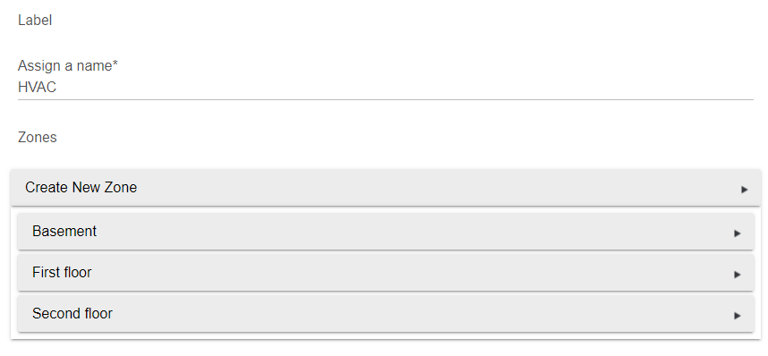

For each zone, you will be asked to give the zone a name and indicate the thermostat for that zone. Every zone is required to have a thermostat.

Then, you must enter a maximum airflow for the zone. As a rule of thumb, count the number of registers in the zone and multiply by 150. If the entered number is less than the air handler generates, then this zone may not be served until other zones also make heating or cooling calls. If the number entered is less than the air handler provides in second stage, then second stage will not be used when this is the only zone calling. If you find that the ducts are excessively noisy when this zone is the only one calling, or if excessive pressure is detected in the duct system, then you need to use a lower number. Alternatively, you can set the dampers for other zones to not close completely. The App needs to know the percent open in the off position for each zone so it can factor that in when deciding whether to serve a call in another small zone. For a single zone system, the maximum airflow must be more than the air handler provides or else heating and cooling calls will not be served. If the zone has subzones, do not count the registers in the subzones. The App will handle adding the capacity of the subzones when they are selected.

You must indicate a switch device for the App to use to select the zone when it is being served. In a multi-zone system, the outputs of these switches will control zone dampers. In a single-zone system, this switch can be ignored. Zone dampers are often normally open dampers meaning that they default to open and must be powered to close. If you tell the App that the zone damper is normally open, it will turn the switch on to close the zone and turn the switch off to select the zone.

Depending on what sensors you have in your home automation system, you may be able to determine when this zone is occupied. If so, it is useful to indicate that to the App so that separate control rules can be used depending on whether or not the zone is occupied. For example, you may want to direct fresh air to the zone when it is occupied but not when it is vacant. The occupied status may be provided to the App by specifying a switch that is on when the zone is occupied and off when the zone is vacant.

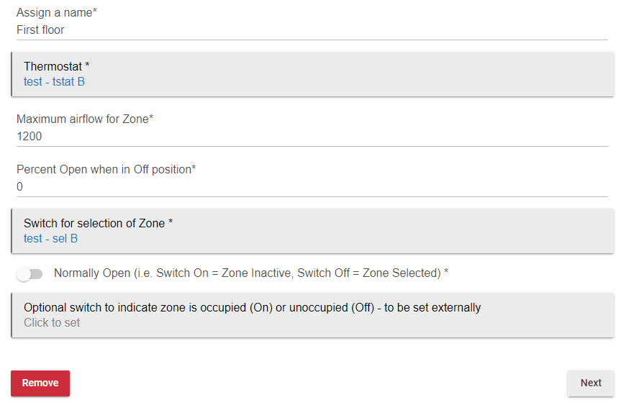

The next section allows you to set up subzones, which is discussed below.

For each zone, you indicate rules for when the zone should volunteer to receive heating or cooling without the thermostat calling for heating or cooling respectively. This can be required in two circumstances. First, if other zones are too small to be served by themselves, the App looks for other zones that volunteer to accept heating or cooling when the small zone’s thermostat calls for it. Second, subzones can only receive heating or cooling when the corresponding main zone is receiving heating or cooling. If a thermostat in a subzone calls for heating and cooling, the App will serve that call only if the corresponding main zone volunteers to receive heating or cooling. Several choices are available. The zone may always volunteer or never volunteer. Alternatively, the zone may volunteer only if it’s own thermostat has generated a heating or cooling call within the last hour, which usually indicates that it is likely to generate another one soon so accepting heating or cooling now is not going to create a comfort problem. Finally, the zone can volunteer based on the current temperature relative to the current setpoint. (This last option is not available for an Indirect Thermostat based on reading the 24VAC thermostat output since the setpoint is not communicated to Hubitat.) Also, you specify in which modes the zone should receive fresh air when the ventilation system is being operated without a heating or cooling call. (This is applicable only for interlocked ventilation systems.)

You may indicate that outputs should be refreshed periodically, even if the state hasn’t changed. This is useful if you are using a ZEN16 as an output and you have activated the feature to have it go to a default state after a period of inactivity. Setting output refresh to a shorter period than the timeout period ensures that the ZEN16 will not go to the default state unless communication with the ZEN16 is lost.

You may also ask for inputs to be polled periodically. Usually, this has no effect because the inputs should report state changes so that the App can act on them immediately. However, if an event is missed for some reason, this allows the App to catch up to the current state. If the input devices support the refresh() function, the App uses that function before retrieving their state. Some thermostats do not reliably update their operating state and temperature unless they get periodic refresh() calls.

When you click Done, the App processes your inputs. Clicking Remove deletes the zone from the App.

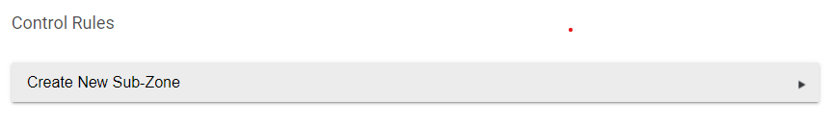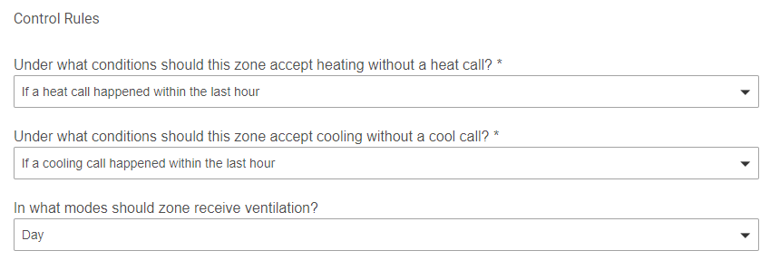 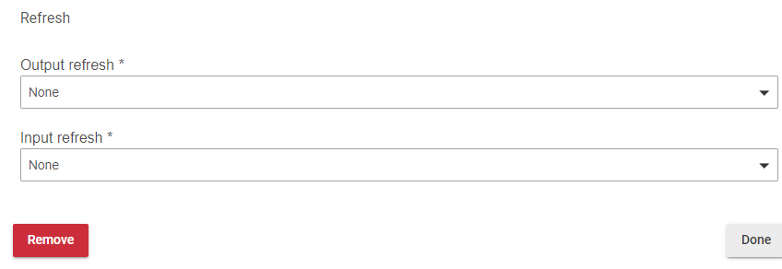

If your zone has subzones (controllable registers or duct fans), then you will need to provide some information.

Next, you need to indicate the maximum airflow and percent open in the closed position. These have the same meaning as they do for regular zones. You must specify a switch device for selecting the zone. If your device does not show up in the list, then create a virtual switch and create rules to manipulate your device based on the virtual switch’s state. If you specify that the device is normally open, then the App will turn the switch on to close the subzone and turn it off to select the subzone.

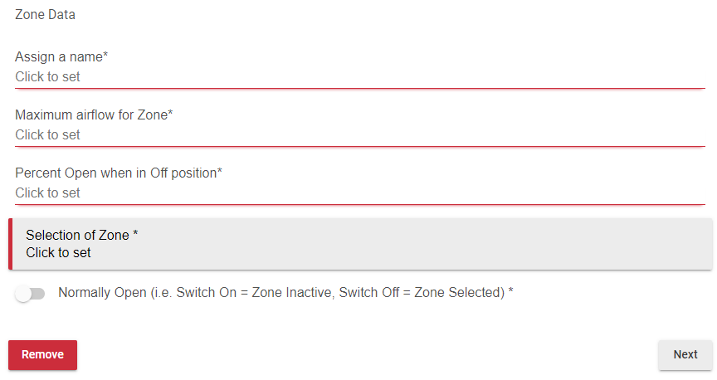

There are two ways to specify the temperature and setpoints for a subzone. You may indicate a separate thermostat for the subzone. Or, you may specify a temperature sensor and indicate the setpoints as offsets from the parent zone setpoints.

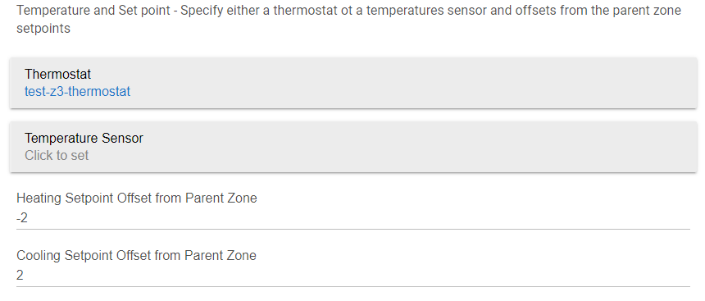

When a parent zone initiates a heating call or cooling call, control rules determine whether the subzone will join that call or not. Joining the call means that the subzone will be selected when the call is served for the subzone. Several options are available. You can indicate that the subzone should join a parent’s heating call only if it also has a heating call, which is only possible if it has a thermostat. Or, you can indicate that the subzone should join a heating call only if its current temperature is currently less than its heating setpoint. Finally, you can indicate that the subzone should join a heating call only if its current temperature no more than 1 degree above its heating setpoint. Similar rules are available for cooling.

If a subzone has a thermostat, then it can initiate heating or cooling calls. As discussed above, these will be served only if the parent zone has volunteered to accept heating or cooling.

Finally, you may optionally specify a switch to indicate whether the subzone is selected during a parent’s fan only call or when the parent is selected for ventilation. If no switch is specified, the subzones is not selected during these events.

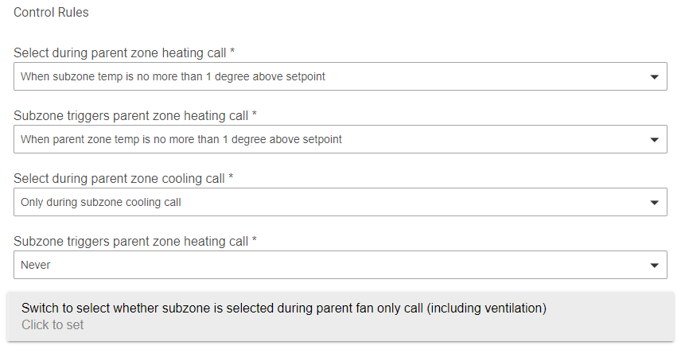

Once the zones and subzones are defined, it is time to return to the settings page for the main App and specify the equipment. For both heating and cooling, you specify whether your equipment is single stage or two stage. If you do not have either heating equipment or cooling equipment, you may specify none. If you have two stage equipment, but it is set up to handle staging logic by itself, then you should specify single stage. Modulating equipment is not currently supported.

For ventilation equipment, you should specify whether the equipment requires the blower to run or not. If you do not have ventilation equipment, or you don’t want the App to control it, then indicate none.

If you have one of your thermostats wired to your equipment, as shown in Examples 1-3, then you should indicate that thermostat on this settings page, even if you already indicated it on the page for the zone. Specifying a wired thermostat on this page tells the App that it should avoid issuing any command that would be incompatible with the command from that thermostat. For example, if that thermostat is calling for heat and another thermostat is calling for cooling, the wired thermostat gets priority.

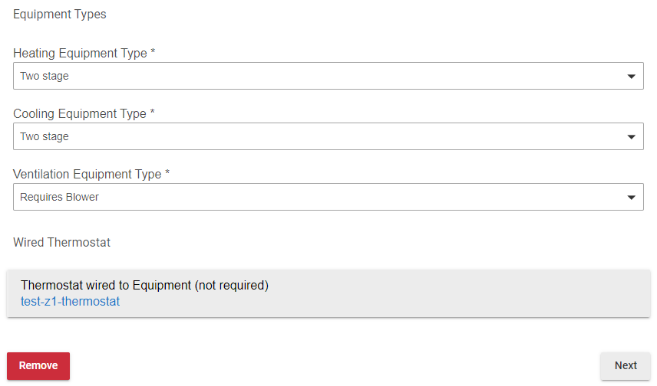

On the next page, you will be asked for more details about the airflow rate provided by your air handler in various modes. Ideally, this data should be obtained from your equipment technical manual. If that is not available, some rules of thumb will likely get close enough that the system operates properly.

The model number of the furnace is usually on a sticker and indicates the nameplate capacity. Model numbers beginning with 040 are 40,000 btu/hr, 060 are 60,000 btu/hr, etc. If you take the number represented by the first three digits of the model number and multiply by 20, that is a decent approximation of the airflow in the highest heating stage. For example, if the model number is 0801716, use 1600 cfm for the airflow of the highest stage. For a two-stage furnace, the airflow for the first stage is about 60% of the airflow for the higher stage. If you have a two stage furnace, but are letting the furnace select stages by itself, then enter it into the App as a single stage with the airflow based on the unit’s second stage.

Air conditioners typically have nameplate capacities in multiples of 12,000 btu per/hr, which is called one ton of cooling capacity. For example a four ton air condition has a nameplate cooling capacity of 48,000 btu/hr. The capacity of an air conditioner, in thousands of btu/hr, is typically indicated by three digits in the model number, starting with a 0. For example, the model number GSXC160361C has a capacity of 36,000 btu/hr, or three tons. The airflow for an air condition is typically about 400 cfm per ton of nameplate capacity in the highest stage. For a two stage air condition, the airflow for the first stage is about 75% of the airflow for the second stage, or about 300 cfm per ton of nameplate capacity. Therefore, if you have a three ton (36,000 btu/hr) two stage air condition, enter 900 cfm for first stage and 1200 cfm for the second stage if you will be letting the App control staging. As with furnaces, if you are going to let the air handler decide when to use second stage, then tell the App that it is a single stage air conditioner and enter the highest stage airflow.

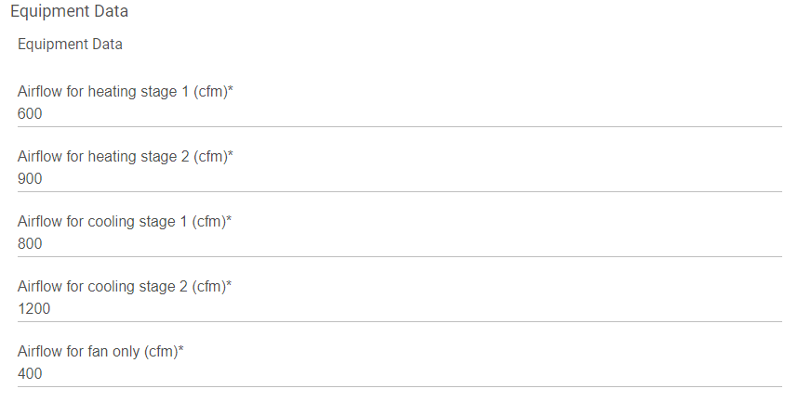

When one or more zones call for heating, the App compares the capacity of the calling zones, plus any capacity of non-selected zones in the off position, to the first stage heating airflow of the air handler. If the capacity is greater than the air handler airflow, then the App serves the heating call by commanding the heating equipment on, selecting the calling zones, and deselecting all other zones. If the capacity is less than the air handler airflow, then the system check to see if any other zones have volunteered to receive heating. If the capacity of the zones calling for heating plus the zones that volunteer to receive the heating is greater than the air handler output, then the call is served. Otherwise, the App waits to serve the call. If some of your zones are smaller than the air handler airflow, be aware that those zones may not get served until other zones also call for heat or volunteer to receive it without a call. When the conditions for second stage heating are satisfied, the App will compare the capacity to the second stage heating airflow of the air handler. If the capacity is less, the second stage will not be commanded.

After you enter the airflow data, you need to specify a switch for each of the outputs. The App will turn these switches on to turn the equipment on. Physically connecting the switch to the equipment is discussed in the previous section. If you have indicated that a thermostat is wired to the equipment, then you have the option of having the App command that thermostat to turn on the fan instead of specifying a switch device.

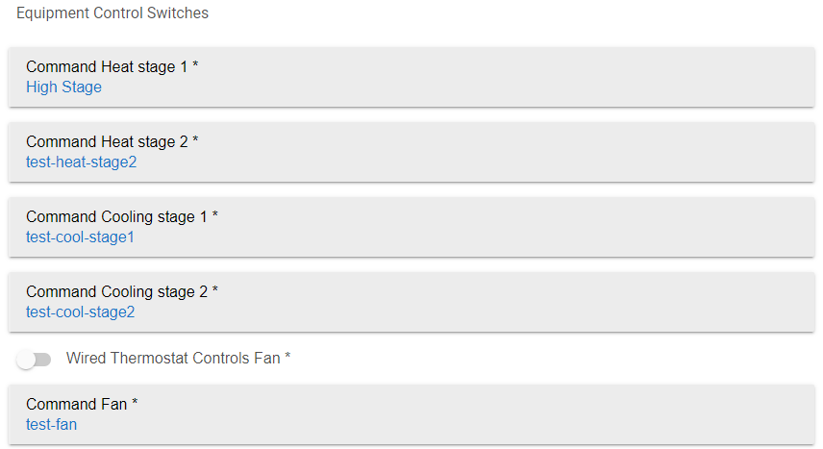

If you have an over-pressure sensor readable by your home automation system, you can optionally indicate that device to the App. If an over-pressure is indicated, the App will adjust to relieve the over-pressure by deselecting stage 2 if it is selected and selecting additional zones.

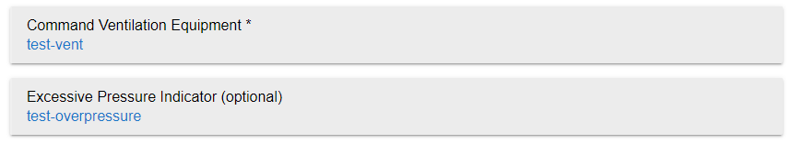

Finally, you need to specify some control parameters. It is hard on equipment to change rapidly between heating and cooling. Sometimes, during transition seasons, one zone may call for heat at the same time that another zone is calling for cooling. You can enter a minimum time between finishing serving a heating or cooling call and starting to serve the opposite type of call. One exception to this happens if you have a thermostat wired to the equipment. If that thermostat calls for heating or cooling, any command for the opposite mode will immediately terminate.

If you indicate two stage heating or cooling equipment, the App will ask for some parameters about when second stage should be used. One parameter is the duration of running in first stage before activating second stage. The second parameter is a temperature difference from setpoint in any zone.

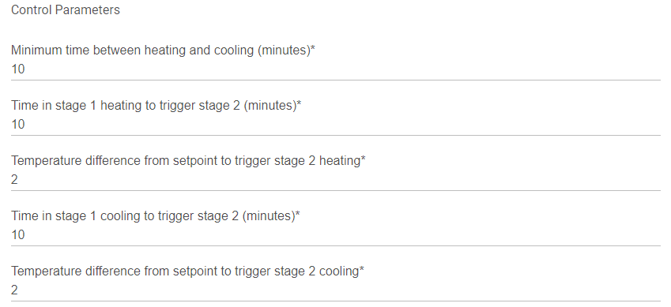

For ventilation, you indicate a dimmer device to indicate the percentage of time that ventilation should run. Dimmer devices are also switch devices, so the control can be used to turn off ventilation if desired. Optionally, you may indicate a switch device for temporary (spot) ventilation. When the spot ventilation switch is on, ventilation runs regardless of the amount of time that it has run recently.

Input and output refresh for the App work the same as they do for zones and subzones.

Finally, you can optionally indicate a device to receive status reports from the App. This is a virtual device using the HVAC Zoning Status device handler. The device has attributes that indicate how much time the system has been calling for cooling, heating, etc. These attributes are set to zero with the reset_runtime() method. This same device is used as an output by the Indirect Thermostat Filler App. The Attributes may be displayed on a dashboard.

